**Assignment 11**

Ø Create IAM User with necessary permissions required for this workshop (VPC, EC2)

Ø Login with created IAM User

Ø Create your own VPC, Subnets, Routetables etc according to requirement below in that account

Ø Create 2 EC2 (Ubuntu 22) within your vpc (different Private Subnet) - Install nginx

Ø Create NLB in Public Subnet

Launch Application (LB DNS)

Ec2 User, Instances (2 private & 1 public)

NLB

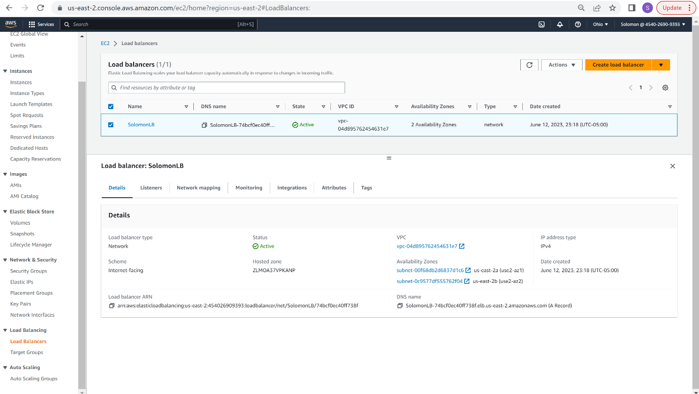

**NGINX Installed**

